A Project Report

On

E - Library Management System

By

Suraj Limbalkar (TE-IT 24)

Kaustubh Lande (TE-IT 22)

Nitish Kumar (TE-IT 28)

Abhishek dombe (TE-IT )

**Under the guidance of**

**Mrs.S.B. Jadhaw**



**Department of Information Technology**

**Sinhgad Institute of Technology, Lonavala**

**SAVITRIBAI PHULE PUNE UNIVERSITY**

**2020-2021**

|  |  |
| --- | --- |
| Sinhgad Technical Education Society,  Department of Information Technology  Sinhgad Institute of Technology, Lonavala. |  |

**CERTIFICATE**

This is to certify that,

Name of the Students:

Suraj Limbalkar (TE-IT 24)

Kaustub Lande (TE-IT 22)

Nitish Kumar (TE-IT 28)

of class T.E IT; have successfully completed their Mini Project Work on “ E - Library Management System OR Electronic - Library Management System (ELMS)” SINHGAD INSTITUTE OF TECHNOLOGY in the partial fulfillment of the Graduate Degree course in T.E at the Department of Information Technology, in the academic Year 2020-2021 Semester – I as prescribed by the Savitribai Phule Pune University.

Prof.Rakesh Badodekar

Mrs.S.B.Jadhaw

Guide Head of the Department

(Department of Information Technology)

**Acknowledgement**

I feel great pleasure in expressing my deepest sense of gratitude and sincere thanks to my guide **Prof. S. Jadhav** for their valuable guidance during the Project work, without which it would have been very difficult task. I have no words to express my sincere thanks for valuable guidance, extreme assistance and cooperation extended to all the **Staff Members** of my Department.

This acknowledgement would be incomplete without expressing my special thanks to **Prof. R. Badodekar** Head of the Department (Information Technology) for their support during the work.

I would also like to extend my heartfelt gratitude to my **Principal, Dr. M. S. Gaikwad** who provided a lot of valuable support, mostly being behind the veils of college bureaucracy.

Last but not least I would like to thanks all the Teaching, Non- Teaching staff members of my Department, my parent and my colleagues those who helped me directly or indirectly for completing of this Project successfully.

Suraj Limbalkar (TE-IT 24)

Kaustub Lande (TE-IT 22)

Nitish Kumar (TE-IT 28)

**Contents**

1. **TITLE OF THE PROJECT**
2. **ABSTRACT**
3. **INTRODUCTION**

* Problem definition

1. **SCOPE**
2. **SPECIFIC REQUIRMENTS**

* Hardware Interface
* Software Interface

1. **THEORY OF SOFTWERE USED**

* java
* MYSQL

1. **DATABASE FORMAT**
2. **ER DIAGRAM**
3. **OUTPUT SCREEN (GUI)**
4. **SAMPLE CODE**
5. **CONCLUSION**
6. **REFERENCES**

**Chapter 1**

**TITLE OF THE PROJECT**

E - Library Management System

**Chapter 2**

**ABSTRACT**

The E - Library Management System or Electronic Library Management System is an application for assisting a librarian in managing a book library in a university. The system would provide basic set of features to add/update members, add/update books, and automate the operations performed over the information about the book issues and returns and all other operations.

Library management system is a typical management Information system (MIS), its Development include the establishment and maintenance of back-end database and front-end application development aspects. This is very difficult to organize manually. Maintenance of all this information manually is a very complex task. This computerization of library helps in many instances of its maintenances. It reduces the workload of management as most of the manual work done is reduced.

**Chapter 3**

**INTRODUCTION**

E - Library Management software for monitoring and controlling the transactions in a library .The project “ E - Library Management System” is developed in **JAVA** and **MySQL**, which mainly focuses on basic operations in a library like adding new books, and updating new information, searching books and members and return books.

This project of “ ELECTRONIC - LIBRARY MANAGEMENT SYSTEM” of gives us the complete information about the library. We can enter the record of new books and retrieve the details of books available in the library. We can issue the books to the students and maintain their records and can also check how many books are issued and stock available in the library. In this project we can maintain the late fine of students who returns the issued books after the due date.

Throughout the project the focus has been on presenting information and comments in an easy and intelligible manner.

**Chapter 4**

**SCOPE**

Due to the many problems facing with the current system by the college, I made a completely new library management system that can produce automated online system for managing the activities of the library system. It is totally secured system that can be accessed only by the verified user putting the user name and password procedure.

**Chapter 5**

**SPECIFIC REQUIRMENTS**

* Hardware Interface:

Processor :Intel

Pentium IV 2.4 GHZ or above

Clock speed:500 MHZ

System bus :32 bits

RAM :256MB of RAM

Monitor :SVGA

Keyboard :108 keys

* Software Interface:

OS :MS WINDOWS 10

Front End :Core Java

Back End :MYSQL

**THEORY OF SOFTWERE USED**

* Java
* MYSQL

**Chapter 6**

**DATABASE FORMAT**

MYSQL

**Librarian :**

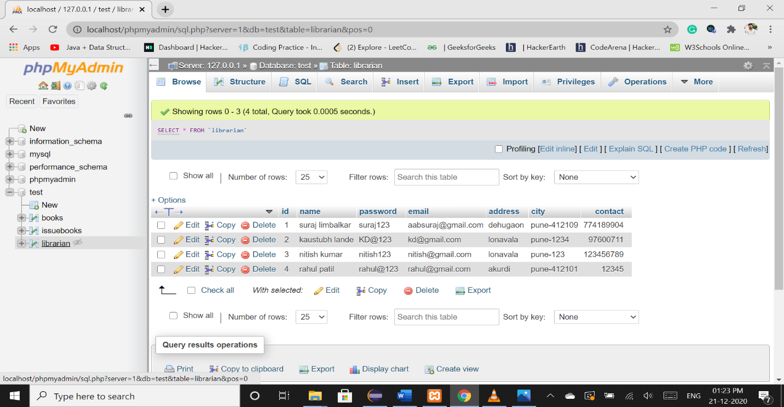

**Books:**

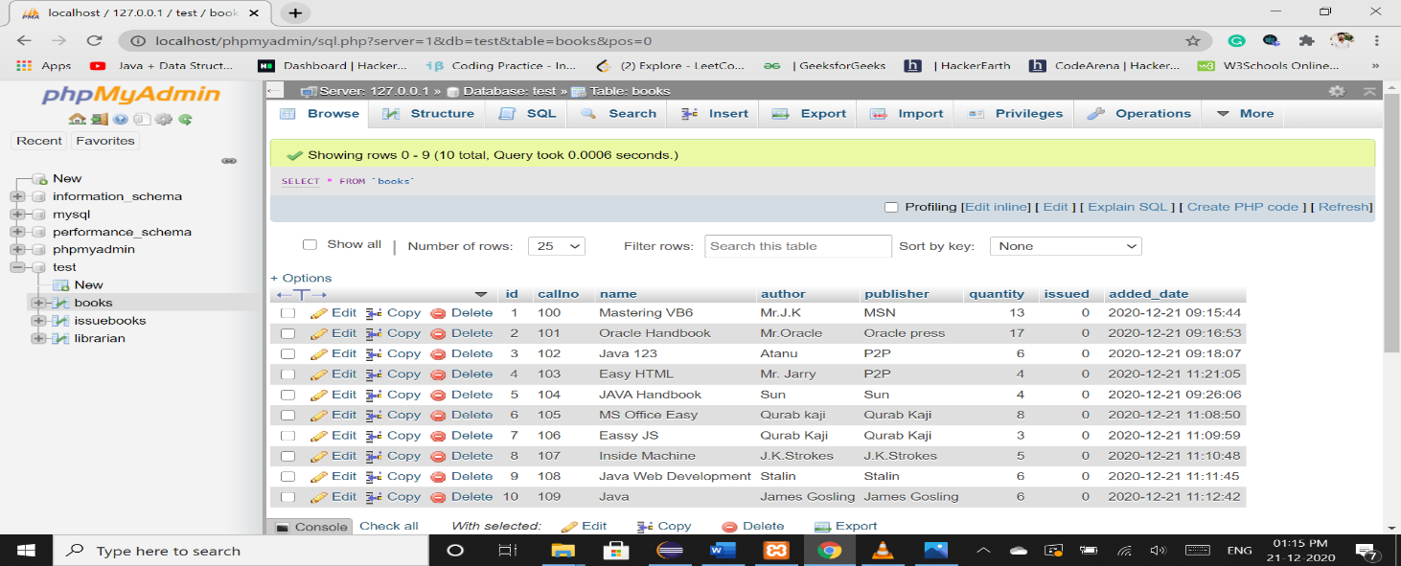

**IssueBooks :**

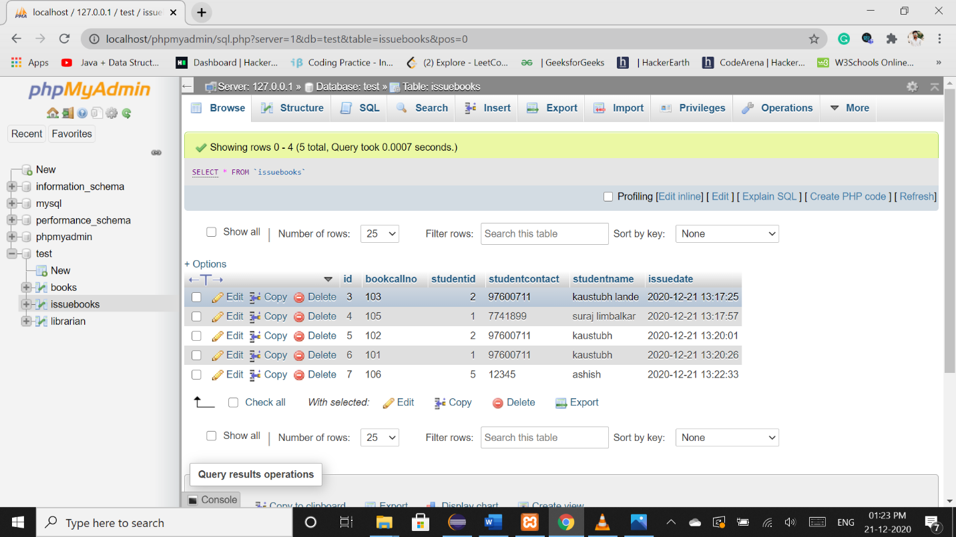

**Chapter 7**

**ER DIAGRAM**

**E - Library Management System**

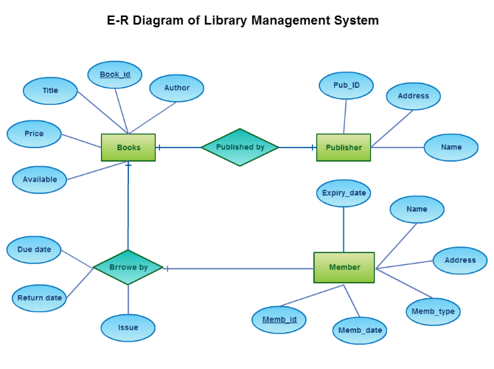

**Chapter 8**

**OUTPUT SCREEN (GUI)**

**Home Screen:**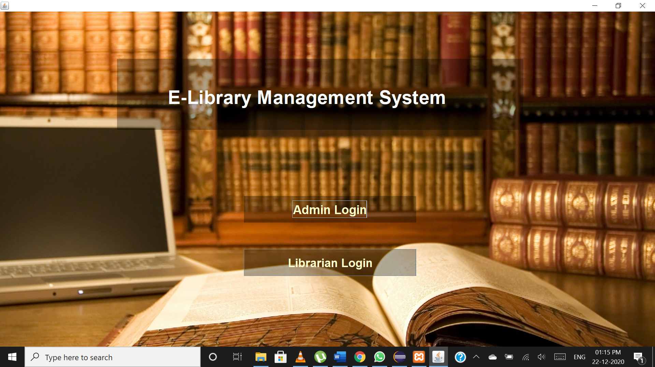

**Admin Login:**

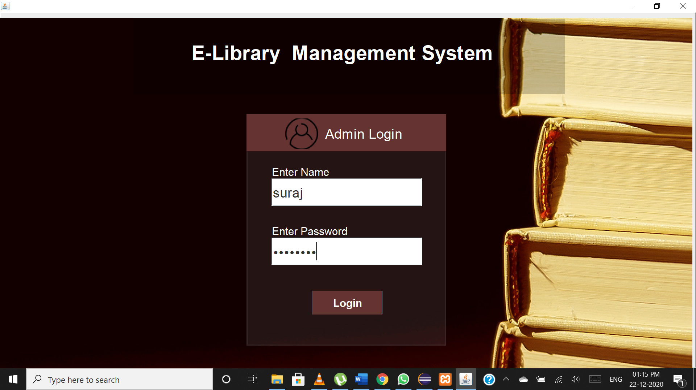

**Admin Section:**

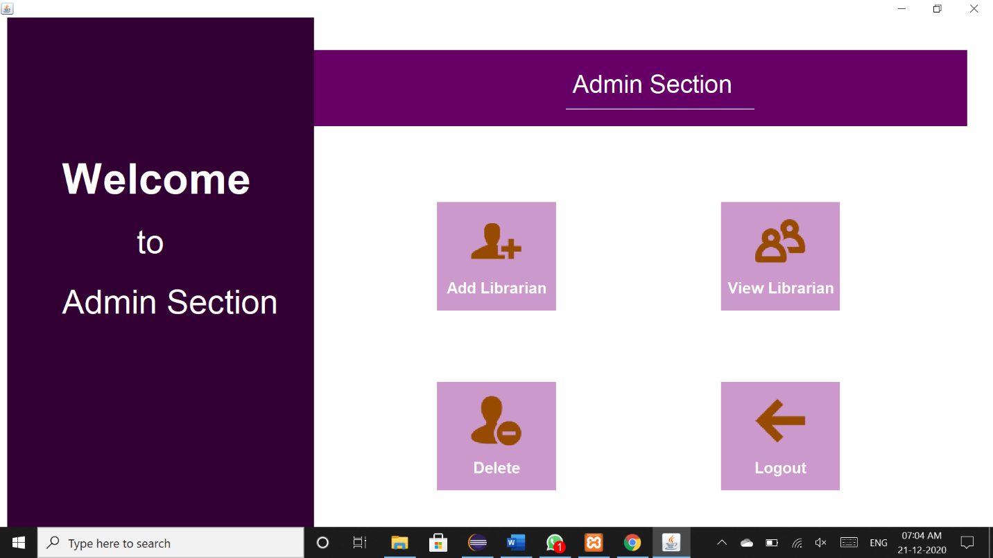

**Add Librarian:**

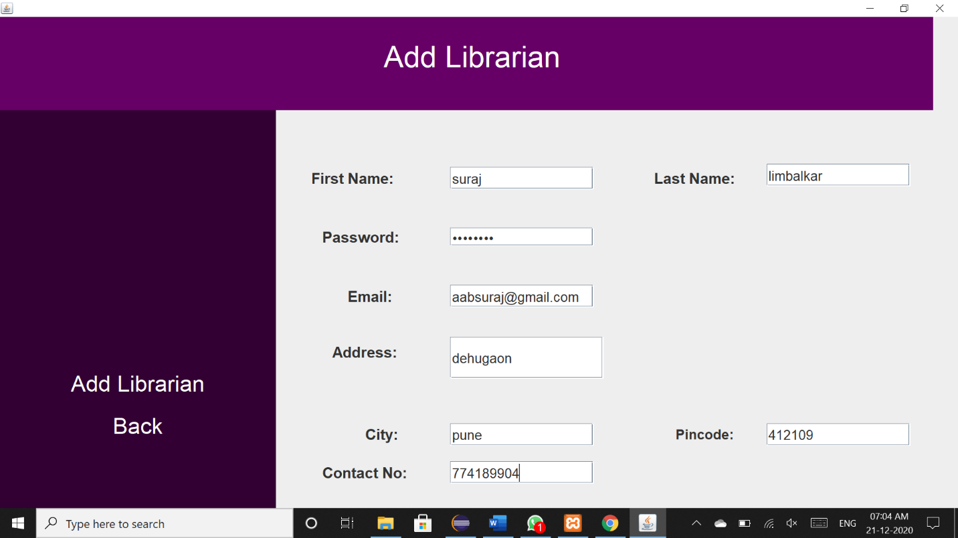

**Delete Librarian:**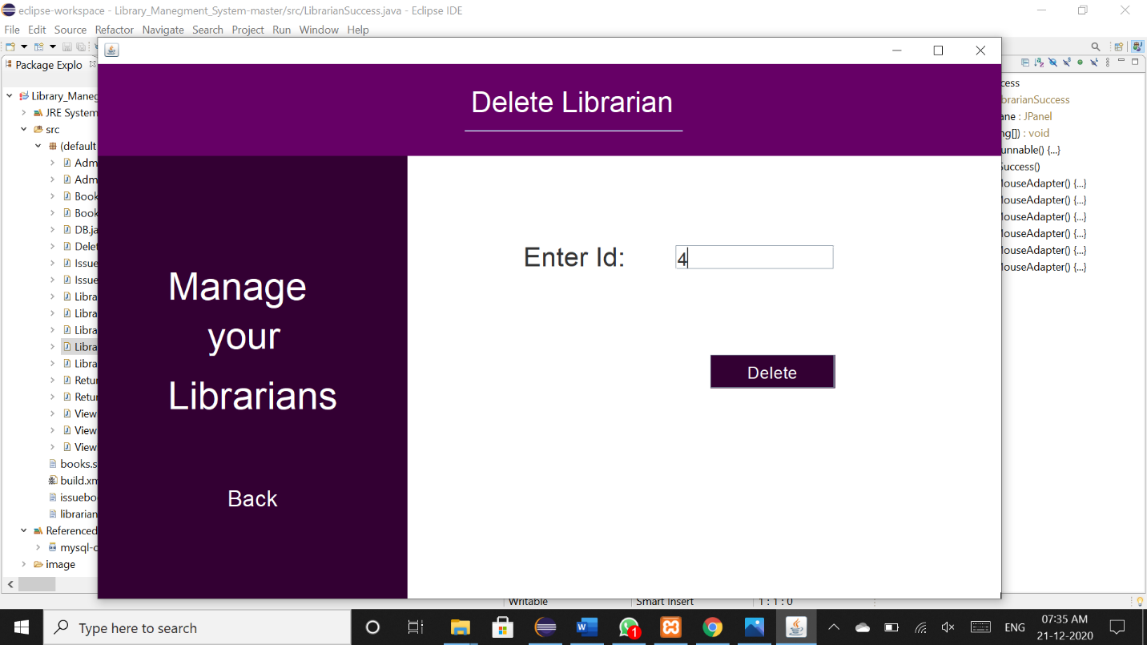

**Librarian Login:**

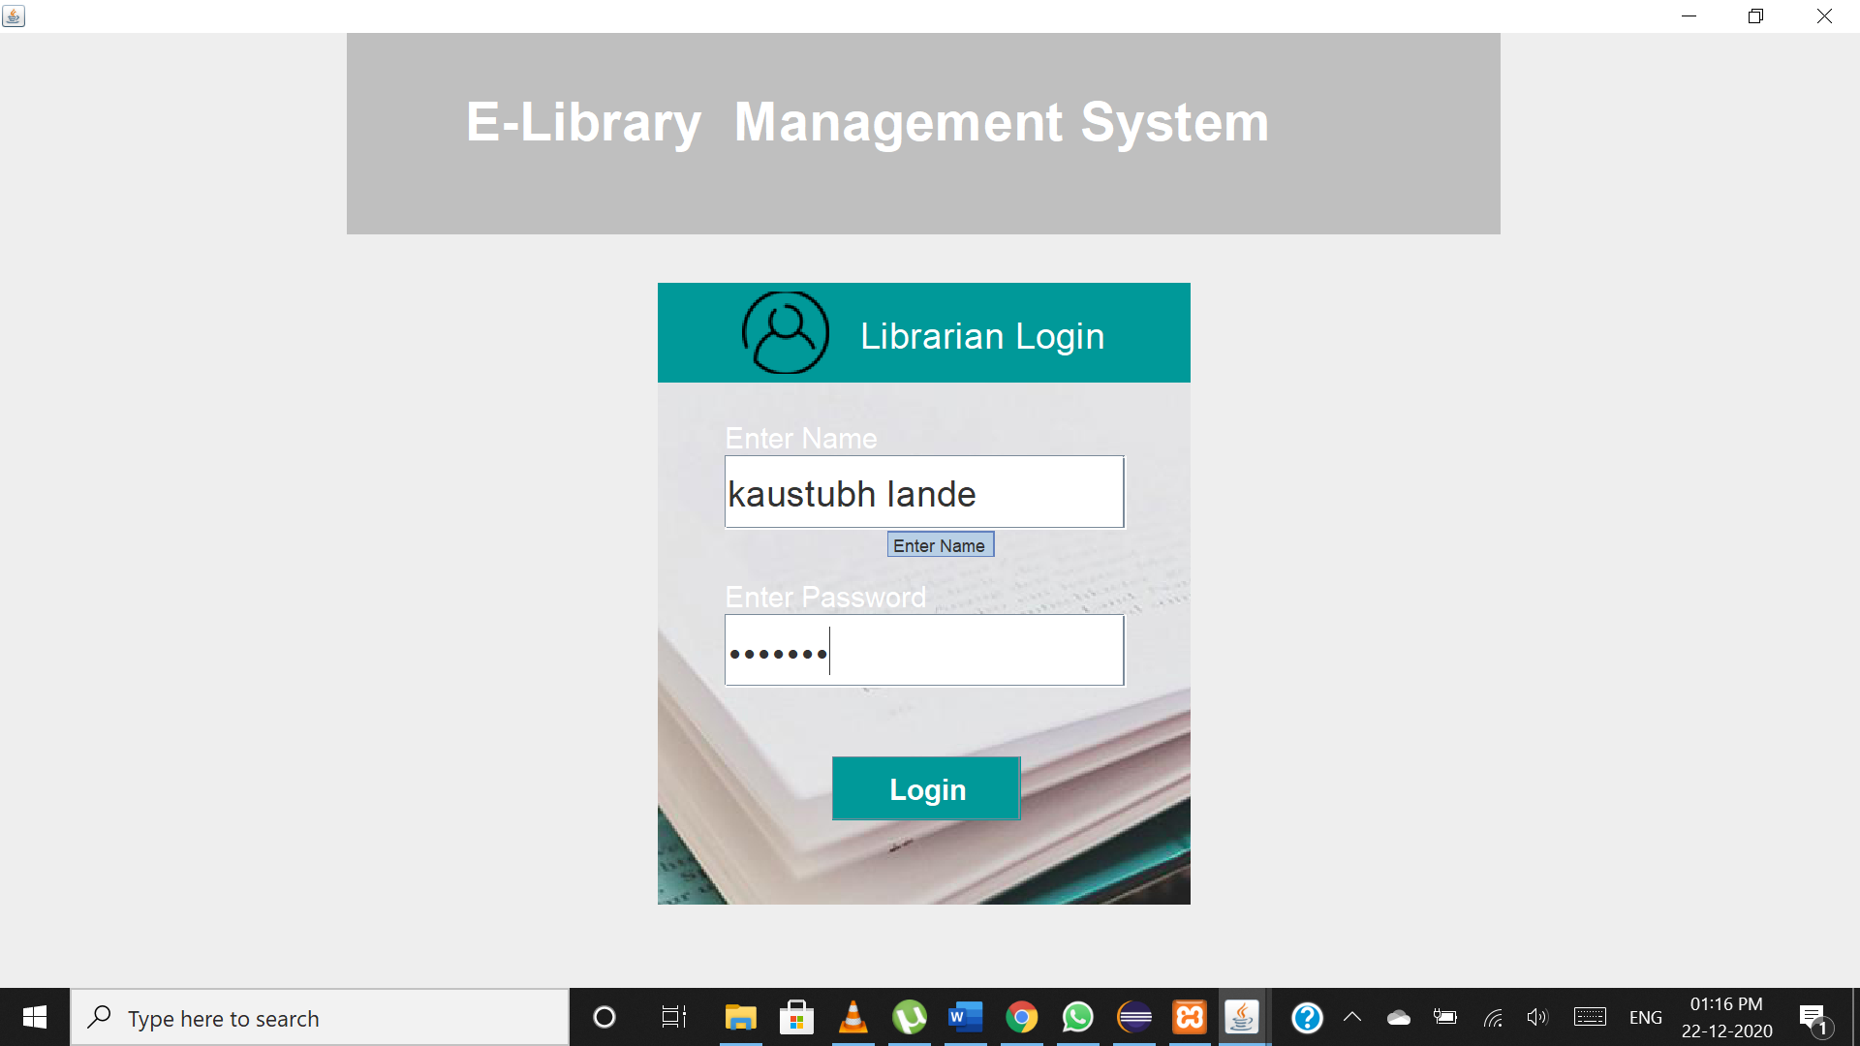

**Librarian Section:**

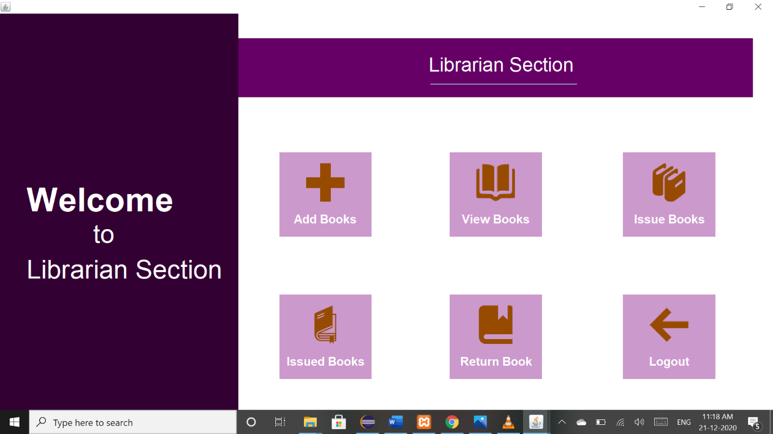

**Add Books:**

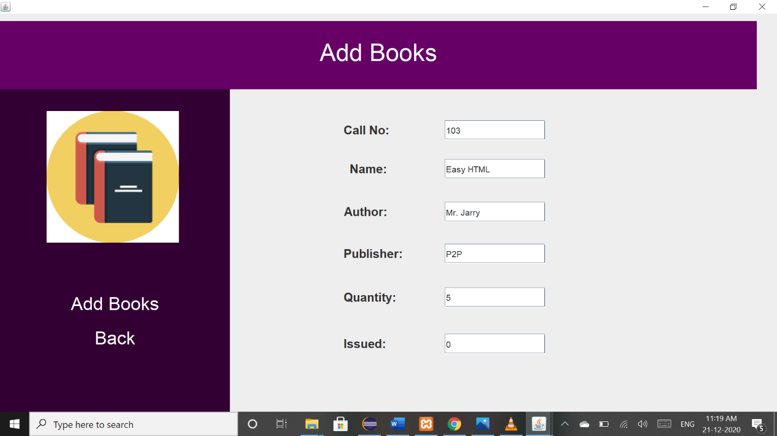

**Views Books:**

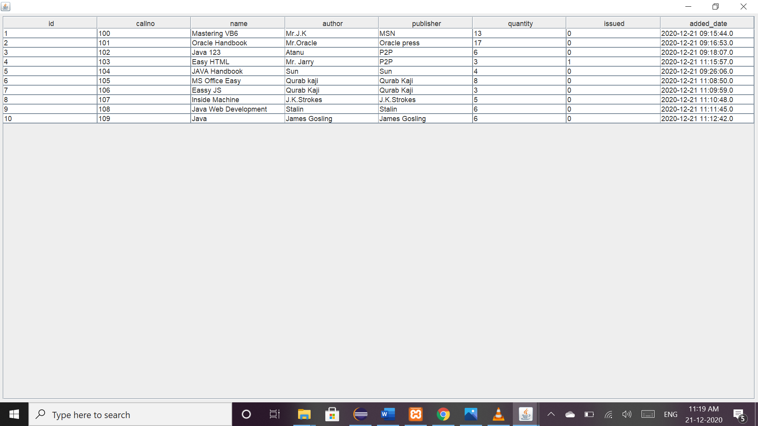

**Issue Books:**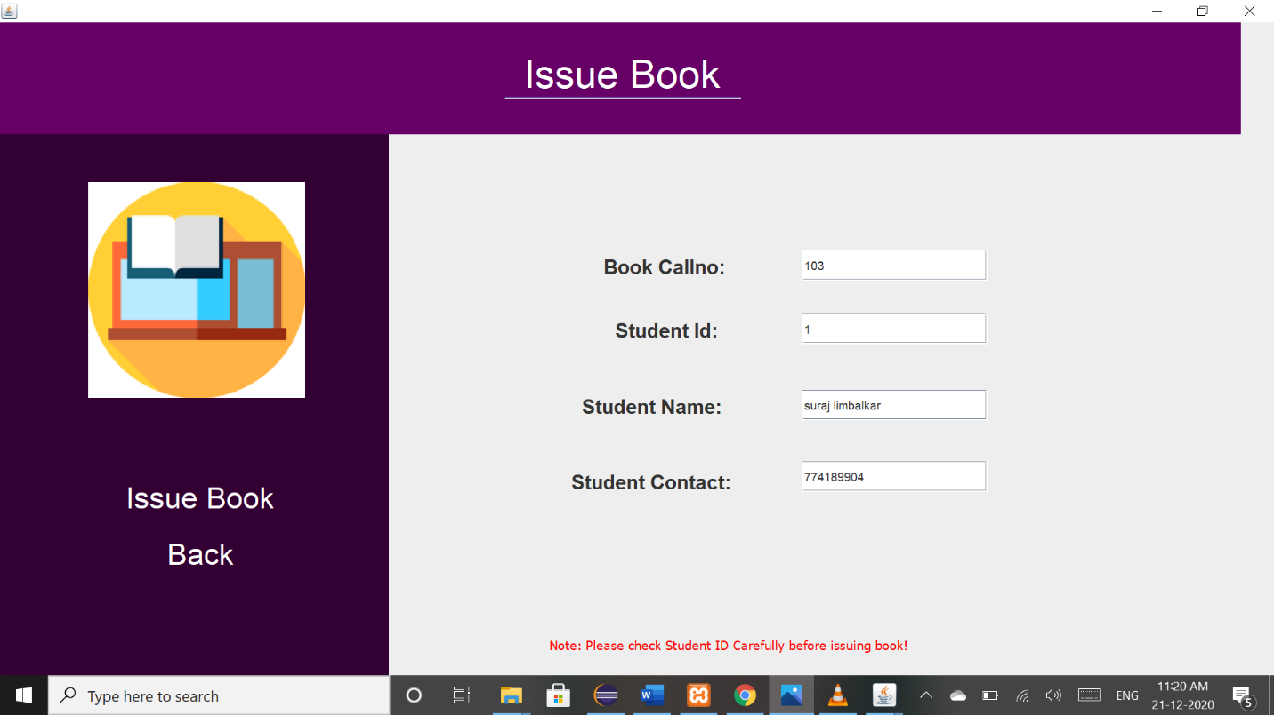

**Issued Books:**

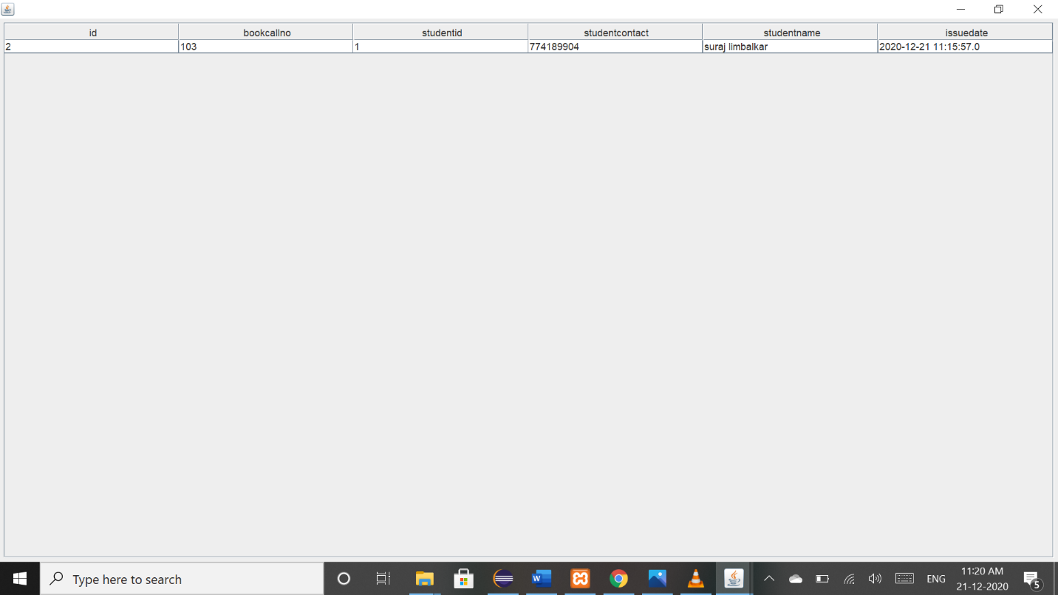

**Return Book:**

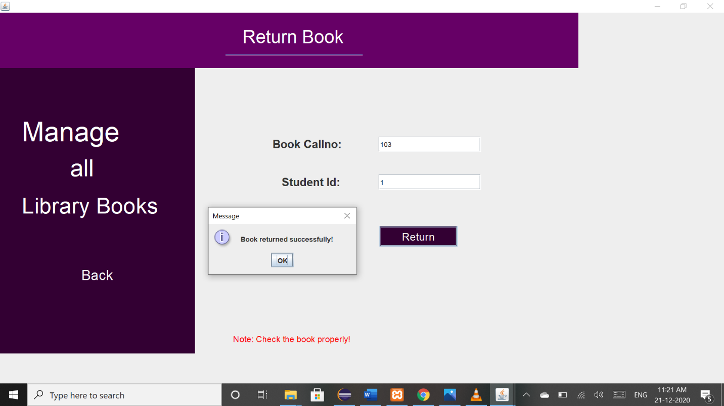

**Chapter 9**

**SAMPLE CODE**

/* Admin Login*/

**import** java.awt.EventQueue;

**import** javax.swing.JFrame;

**import** javax.swing.JPanel;

**import** javax.swing.JLabel;

**import** javax.swing.JOptionPane;

**import** java.awt.Font;

**import** java.awt.Color;

**import** javax.swing.JTextField;

**import** javax.swing.JButton;

**import** java.awt.event.ActionListener;

**import** java.awt.event.ActionEvent;

**import** javax.swing.JPasswordField;

**import** javax.swing.border.BevelBorder;

**import** javax.swing.ImageIcon;

**import** javax.swing.UIManager;

**public** **class** AdminLogin **extends** JFrame {

**static** AdminLogin *frame*;

**private** JPanel contentPane;

**private** JTextField textField;

**private** JPasswordField passwordField;

/**

* Launch the application.

*/

**public** **static** **void** main(String[] args) {

EventQueue.*invokeLater*(**new** Runnable() {

**public** **void** run() {

**try** {

*frame* = **new** AdminLogin();

*frame*.setVisible(**true**);

} **catch** (Exception e) {

e.printStackTrace();

}

}

});

}

/**

* Create the frame.

*/

**public** AdminLogin() {

setDefaultCloseOperation(JFrame.***EXIT_ON_CLOSE***);

setBounds(100, 100, 1247,699);

contentPane = **new** JPanel();

contentPane.setBorder(**new** BevelBorder(BevelBorder.***RAISED***, **null**, **null**, **null**, **null**));

setContentPane(contentPane);

contentPane.setLayout(**null**);

JPanel panel = **new** JPanel();

panel.setBorder(**new** BevelBorder(BevelBorder.***RAISED***, **null**, **null**, **null**, **null**));

panel.setBackground(**new** Color(255, 255, 255,20));

panel.setBounds(454, 188, 367, 428);

contentPane.add(panel);

panel.setLayout(**null**);

textField = **new** JTextField();

textField.setFont(**new** Font("FreeSans", Font.***PLAIN***, 25));

textField.setToolTipText("Enter Name");

textField.setColumns(10);

textField.setBounds(46, 119, 277, 51);

panel.add(textField);

JButton btnLogin = **new** JButton("Login");

btnLogin.setFont(**new** Font("FreeSans", Font.***BOLD***, 20));

btnLogin.setForeground(**new** Color(255, 255, 255));

btnLogin.setBackground(**new** Color(102, 51, 51));

btnLogin.setBounds(120, 326, 130, 44);

panel.add(btnLogin);

btnLogin.addActionListener(**new** ActionListener() {

**public** **void** actionPerformed(ActionEvent e) {

String name=textField.getText();

String password=String.*valueOf*(passwordField.getPassword());

**if**(name.equals("admin")&&password.equals("admin123")){

AdminSuccess.*main*(**new** String[]{});

*frame*.dispose();

}**if**(name.equals("suraj")&&password.equals("suraj123")){

AdminSuccess.*main*(**new** String[]{});

*frame*.dispose();

}**else**{

JOptionPane.*showMessageDialog*(AdminLogin.**this**, "Sorry, Username or Password Error","Login Error!", JOptionPane.***ERROR_MESSAGE***);

textField.setText("");

passwordField.setText("");

}

}

});

JPanel panel_1 = **new** JPanel();

panel_1.setBackground(**new** Color(102, 51, 51));

panel_1.setBounds(0, 0, 367, 69);

panel.add(panel_1);

panel_1.setLayout(**null**);

JLabel lblAdminLoginForm = **new** JLabel("Admin Login");

lblAdminLoginForm.setForeground(**new** Color(255, 255, 255));

lblAdminLoginForm.setFont(**new** Font("Liberation Sans", Font.***PLAIN***, 25));

lblAdminLoginForm.setBounds(144, 8, 160, 55);

panel_1.add(lblAdminLoginForm);

JLabel lblNewLabel = **new** JLabel("");

lblNewLabel.setBounds(71, 8, 69, 57);

panel_1.add(lblNewLabel);

lblNewLabel.setBackground(Color.***WHITE***);

lblNewLabel.setIcon(**new** ImageIcon("image/icon.png"));

JLabel lblEnterName = **new** JLabel("Enter Name");

lblEnterName.setForeground(Color.***WHITE***);

lblEnterName.setFont(**new** Font("FreeSans", Font.***PLAIN***, 20));

lblEnterName.setBounds(46, 94, 204, 24);

panel.add(lblEnterName);

JLabel lblEnterPassword = **new** JLabel("Enter Password");

lblEnterPassword.setForeground(Color.***WHITE***);

lblEnterPassword.setFont(**new** Font("FreeSans", Font.***PLAIN***, 20));

lblEnterPassword.setBounds(46, 203, 204, 24);

panel.add(lblEnterPassword);

JPanel panel_2 = **new** JPanel();

panel_2.setBounds(245, 12, 794, 139);

contentPane.add(panel_2);

panel_2.setLayout(**null**);

panel_2.setBorder(UIManager.*getBorder*("Menu.border"));

panel_2.setBackground(**new** Color(0, 0, 0, 50));

JLabel lab = **new** JLabel("E-Library Management System ");

lab.setForeground(Color.***WHITE***);

lab.setFont(**new** Font("Chilanka", Font.***BOLD***, 37));

lab.setBounds(132, 31, 509, 63);

panel_2.add(lab);

JLabel lblNewLabel_1 = **new** JLabel("");

lblNewLabel_1.setIcon(**new** ImageIcon("image/img2.jpg"));

lblNewLabel_1.setBounds(-274, 0, 1521, 657);

contentPane.add(lblNewLabel_1);

passwordField = **new** JPasswordField();

passwordField.setFont(**new** Font("FreeSans", Font.***PLAIN***, 25));

passwordField.setToolTipText("Enter Password");

passwordField.setBounds(46, 228, 277, 51);

panel.add(passwordField);

}

}

/* Librarian Login*/

**import** java.awt.BorderLayout;

**import** java.awt.EventQueue;

**import** javax.swing.JFrame;

**import** javax.swing.JPanel;

**import** javax.swing.border.EmptyBorder;

**import** javax.swing.GroupLayout;

**import** javax.swing.GroupLayout.Alignment;

**import** javax.swing.JLabel;

**import** javax.swing.JOptionPane;

**import** java.awt.Font;

**import** java.awt.Color;

**import** javax.swing.JTextField;

**import** javax.swing.JButton;

**import** java.awt.event.ActionListener;

**import** java.awt.event.ActionEvent;

**import** javax.swing.JPasswordField;

**import** javax.swing.border.BevelBorder;

**import** javax.swing.ImageIcon;

**import** javax.swing.UIManager;

**public** **class** LibrarianLogin **extends** JFrame {

**static** LibrarianLogin *frame*;

**private** JPanel contentPane;

**private** JTextField textField;

**private** JPasswordField passwordField;

/**

Launch the application.

*/

**public** **static** **void** main(String[] args) {

EventQueue.*invokeLater*(**new** Runnable() {

**public** **void** run() {

**try** {

*frame* = **new** LibrarianLogin();

*frame*.setVisible(**true**);

} **catch** (Exception e) {

e.printStackTrace();

}

}

});

}

/**

* Create the frame.

*/

**public** LibrarianLogin() {

setDefaultCloseOperation(JFrame.***EXIT_ON_CLOSE***);

setBounds(100, 100, 1247,699);

contentPane = **new** JPanel();

contentPane.setBorder(**new** EmptyBorder(5, 5, 5, 5));

setContentPane(contentPane);

contentPane.setLayout(**null**);

JPanel panel = **new** JPanel();

panel.setLayout(**null**);

panel.setBorder(**new** BevelBorder(BevelBorder.***RAISED***, **null**, **null**, **null**, **null**));

panel.setBackground(**new** Color(0,0,0, 50));

panel.setBounds(453, 172, 367, 428);

contentPane.add(panel);

textField = **new** JTextField();

textField.setToolTipText("Enter Name");

textField.setFont(**new** Font("FreeSans", Font.***PLAIN***, 25));

textField.setColumns(10);

textField.setBounds(46, 119, 277, 51);

panel.add(textField);

JButton button = **new** JButton("Login");

button.addActionListener(**new** ActionListener() {

**public** **void** actionPerformed(ActionEvent e) {

String name=textField.getText();

String password=String.*valueOf*(passwordField.getPassword());

//System.out.println(name+" "+password);

**if**(LibrarianDao.*validate*(name, password)){

LibrarianSuccess.*main*(**new** String[]{});

*frame*.dispose();

}**else**{

JOptionPane.*showMessageDialog*(LibrarianLogin.**this**, "Sorry, Username or Password Error","Login Error!", JOptionPane.***ERROR_MESSAGE***);

textField.setText("");

passwordField.setText("");

}

}

});

button.setForeground(Color.***WHITE***);

button.setFont(**new** Font("FreeSans", Font.***BOLD***, 20));

button.setBackground(**new** Color(0, 153, 153));

button.setBounds(120, 326, 130, 44);

panel.add(button);

JPanel panel_1 = **new** JPanel();

panel_1.setLayout(**null**);

panel_1.setBackground(**new** Color(0, 153, 153));

panel_1.setBounds(0, 0, 367, 69);

panel.add(panel_1);

JLabel lblLibrarianLogin = **new** JLabel("Librarian Login");

lblLibrarianLogin.setForeground(Color.***WHITE***);

lblLibrarianLogin.setFont(**new** Font("Liberation Sans", Font.***PLAIN***, 25));

lblLibrarianLogin.setBounds(139, 8, 183, 55);

panel_1.add(lblLibrarianLogin);

JLabel label_1 = **new** JLabel("");

label_1.setIcon(**new** ImageIcon("image/icon.png"));

label_1.setBackground(Color.***WHITE***);

label_1.setBounds(58, 6, 69, 57);

panel_1.add(label_1);

JLabel label_2 = **new** JLabel("Enter Name");

label_2.setForeground(Color.***WHITE***);

label_2.setFont(**new** Font("FreeSans", Font.***PLAIN***, 20));

label_2.setBounds(46, 94, 204, 24);

panel.add(label_2);

JLabel label_3 = **new** JLabel("Enter Password");

label_3.setForeground(Color.***WHITE***);

label_3.setFont(**new** Font("FreeSans", Font.***PLAIN***, 20));

label_3.setBounds(46, 203, 204, 24);

panel.add(label_3);

passwordField = **new** JPasswordField();

passwordField.setToolTipText("Enter Password");

passwordField.setFont(**new** Font("FreeSans", Font.***PLAIN***, 25));

passwordField.setBounds(46, 228, 277, 51);

panel.add(passwordField);

JPanel panel_2 = **new** JPanel();

panel_2.setLayout(**null**);

panel_2.setBorder(UIManager.*getBorder*("Menu.border"));

panel_2.setBackground(**new** Color(0, 0, 0, 50));

panel_2.setBounds(239, 0, 794, 139);

contentPane.add(panel_2);

JLabel label = **new** JLabel("E-Library Management System ");

label.setForeground(Color.***WHITE***);

label.setFont(**new** Font("Chilanka", Font.***BOLD***, 37));

label.setBounds(121, 29, 488, 63);

panel_2.add(label);

JLabel label_4 = **new** JLabel("");

label_4.setBounds(-396, 0, 1521, 669);

contentPane.add(label_4);

label_4.setIcon(**new** ImageIcon("image/img3.jpg"));

}

}

/* Main Page */

**import** java.awt.EventQueue;

**import** javax.swing.JFrame;

**import** javax.swing.JPanel;

**import** javax.swing.border.EmptyBorder;

**import** javax.swing.ImageIcon;

**import** javax.swing.JLabel;

**import** java.awt.Color;

**import** java.awt.Font;

**import** javax.swing.JButton;

**import** java.awt.event.ActionListener;

**import** java.awt.event.ActionEvent;

**import** javax.swing.SwingConstants;

**import** javax.swing.UIManager;

**public** **class** Library **extends** JFrame {

**static** Library *frame*;

**private** JPanel contentPane;

/**

* Launch the application.

*/

**public** **static** **void** main(String[] args) {

EventQueue.*invokeLater*(**new** Runnable() {

**public** **void** run() {

**try** {

*frame*= **new** Library();

*frame*.setVisible(**true**);

} **catch** (Exception e) {

e.printStackTrace();

}

}

});

}

/**

* Create the frame.

*/

**public** Library() {

setDefaultCloseOperation(JFrame.***EXIT_ON_CLOSE***);

setBounds(100, 100, 1247, 699);

contentPane = **new** JPanel();

contentPane.setBackground(**new** Color(255, 255, 255));

contentPane.setBorder(**new** EmptyBorder(5, 5, 5, 5));

setContentPane(contentPane);

JButton btnAdminLogin = **new** JButton("Admin Login");

btnAdminLogin.setBackground(**new** Color(0, 0, 0,80));

btnAdminLogin.setForeground(**new** Color(255, 255, 204));

btnAdminLogin.setBounds(477, 362, 337, 52);

btnAdminLogin.setBorderPainted(**false**);

btnAdminLogin.addActionListener(**new** ActionListener() {

**public** **void** actionPerformed(ActionEvent e) {

AdminLogin.*main*(**new** String[]{});

*frame*.dispose();

}

});

btnAdminLogin.setFont(**new** Font("Century Schoolbook L", Font.***BOLD***, 24));

JButton btnLibrarianLogin = **new** JButton("Librarian Login");

btnLibrarianLogin.setForeground(**new** Color(255, 255, 204));

btnLibrarianLogin.setBackground(**new** Color(0, 0,0,80));

btnLibrarianLogin.setBounds(477, 466, 337, 53);

btnLibrarianLogin.addActionListener(**new** ActionListener() {

**public** **void** actionPerformed(ActionEvent arg0) {

LibrarianLogin.*main*(**new** String[]{});

}

});

btnLibrarianLogin.setFont(**new** Font("Century Schoolbook L", Font.***BOLD***, 23));

contentPane.setLayout(**null**);

contentPane.add(btnLibrarianLogin);

contentPane.add(btnAdminLogin);

JPanel panel_1 = **new** JPanel();

panel_1.setBorder(UIManager.*getBorder*("Menu.border"));

panel_1.setBackground(**new** Color(0, 0,0,80));

panel_1.setBounds(229, 93, 794, 139);

contentPane.add(panel_1);

panel_1.setLayout(**null**);

JLabel lblLibraryManagement = **new** JLabel("E-Library Management System");

lblLibraryManagement.setBounds(127, 43, 482, 63);

panel_1.add(lblLibraryManagement);

lblLibraryManagement.setForeground(**new** Color(255, 255, 255));

lblLibraryManagement.setFont(**new** Font("Chilanka", Font.***BOLD***, 37));

JLabel lblNewLabel = **new** JLabel("",**new** ImageIcon("image/img1.jpg"),SwingConstants.***CENTER***);

lblNewLabel.setForeground(**new** Color(0, 0, 0));

lblNewLabel.setBounds(-18,-80,1343,749);

contentPane.add(lblNewLabel);

}

}

**Chapter 10**

**CONCLUSION**

E- Library Management System allows the user to store the book details and the person’s details.

• This software allows storing the details of all the data related to library.

• The implementation of the system will reduce data entry time and provide readily calculated reports.

**REFERENCES**

* + [**http://stackoverflow.com**](http://stackoverflow.com)
  + **https://www.geeksforgeeks.org/**
  + **https://youtu.be/x7SwgcpACng**
  + [**https://youtu.be/x8GiogC4SdE**](https://youtu.be/x8GiogC4SdE)
  + **https://youtu.be/5o3fMLPY7qY**